Name Date

Practice A

2.1

Multiply. Write the answer in simplest form.

1.  2.  3. 

4.  5.  6. 

7.  8.  9. 

10. Two-fifths of the students in your class are in the band. Of these, one-fourth   
play the saxophone.

a. What fraction of your class plays the saxophone?

b. There are 30 students in your class. How many students in your class play the saxophone?

11. Five years ago, an alligator was  feet long. Today, the alligator is three times longer. How long is the alligator now?

12. A poster is  inches by 11 inches. You enlarge the poster by increasing each dimension by a factor of . What is the area of the new poster?

Name Date

Practice B

2.1

Multiply. Write the answer in simplest form.

1.  2.  3. 

4.  5.  6. 

8. One-half of your CDs are scratched. Of those, one-fifth will not play properly. You have 40 CDs. How many of them will not play properly?

9. Find the area of the shaded region. Explain how you found the area.

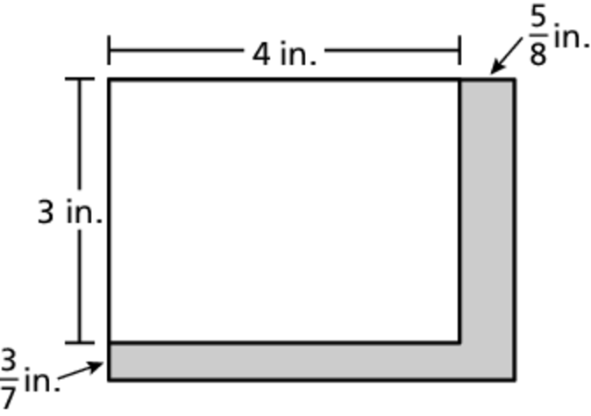

Multiply. Write the answer in simplest form.

10.  12.  13. 