Name Date
Practice A
4.1
Find the area of the parallelogram.
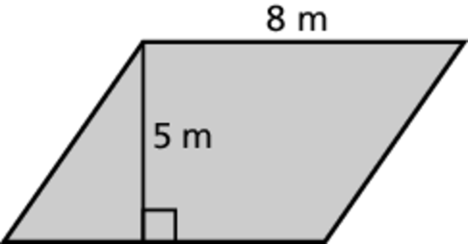
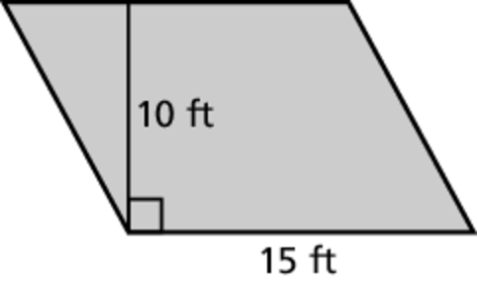
1. 2.
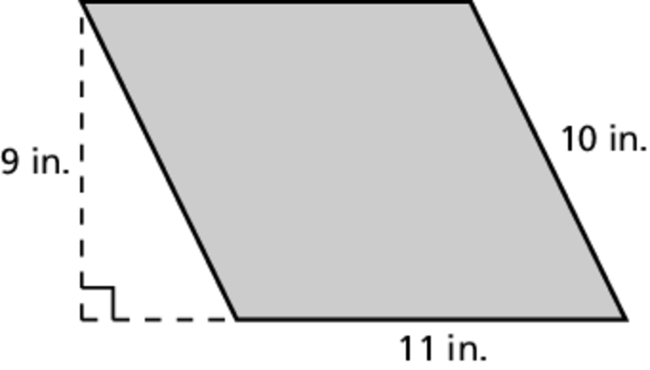
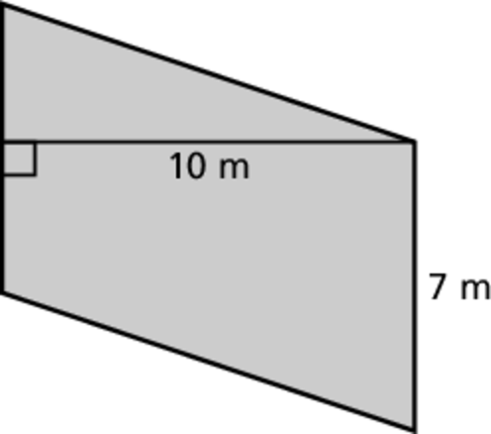
3. 4.
Find the area of the parallelogram.
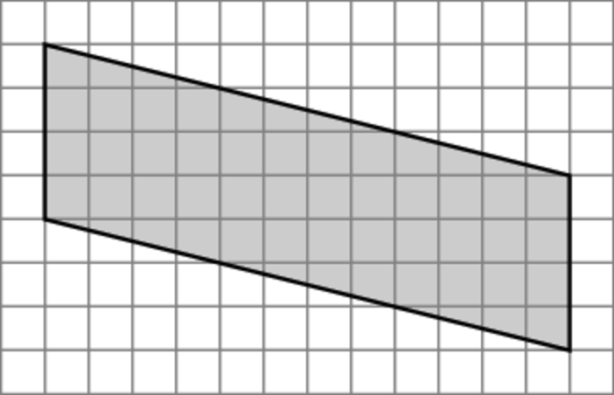
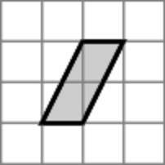
6. 7.
8. A square has side length 6 inches. A parallelogram has a base of 6 inches. The area of the square is equal to the area of the parallelogram. What is the height of the parallelogram?

Find the area of the shaded region.
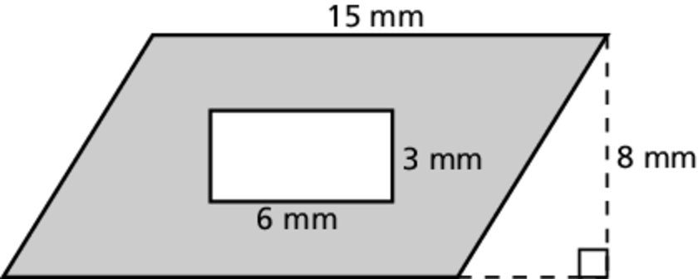
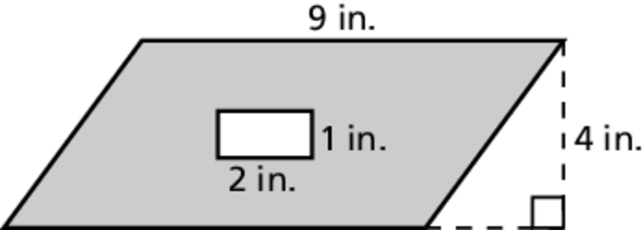
9. 10.

Name Date
Practice B
4.1
Find the area of the parallelogram.
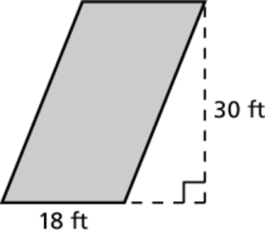
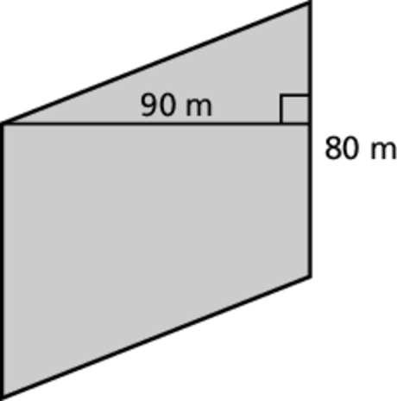
1. 2.
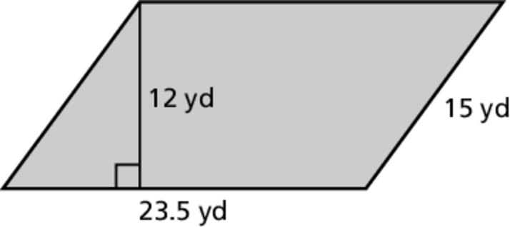
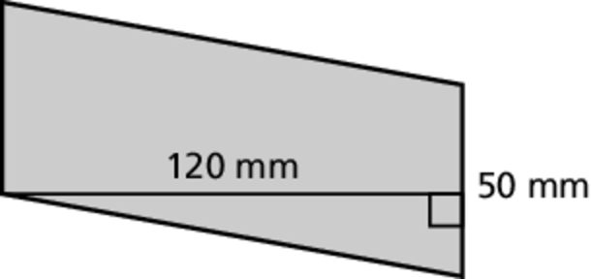
3. 4.
5. A billboard is in the shape of a parallelogram. The billboard has a base of
48 feet and a height of 14 feet. Find the area of the billboard.
Find the area of the shaded region.
6. 7.
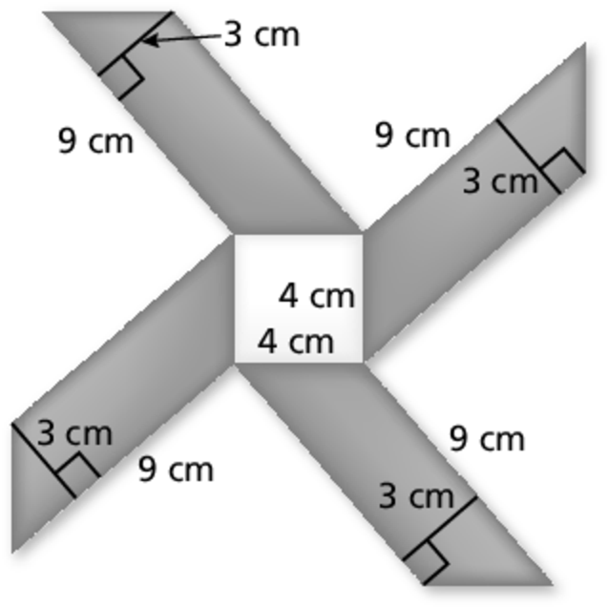
8. The mosaic tile design consists of one square and four parallelograms. Find the area of the design.

