Name Date
Practice A
4.2
Find the area of the triangle.
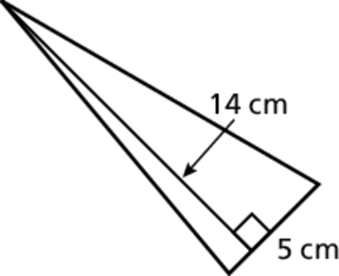
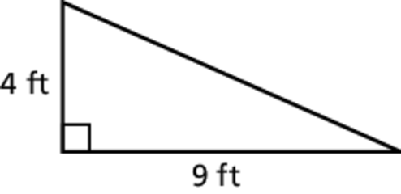
1. 2.
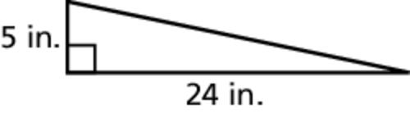
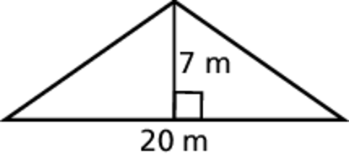
3. 4.

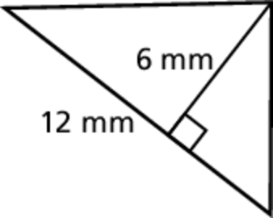
5. Find the area of each triangle. Are the areas the same? Explain.
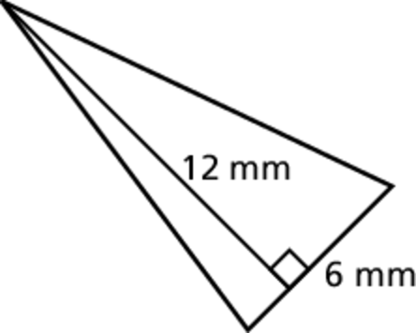

6. Triangle A and Triangle B have the same base. The height of Triangle B
is twice the height of Triangle A. How many times greater is the area of Triangle B?

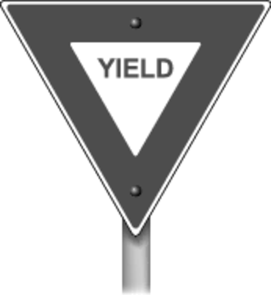
7. The shaded triangle in the sign has a base of
75 millimeters and a height of 65 millimeters.
The white triangle in the sign has a base of
37 millimeters and a height of 32 millimeters.
Find the area of the shaded portion of the sign.
Name Date
Practice B
4.2
Find the area of the triangle.
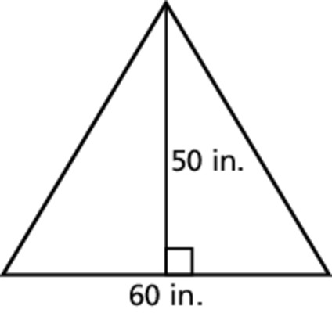
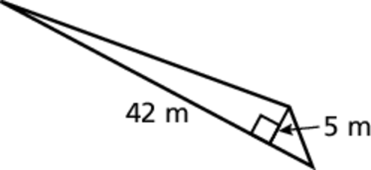
1. 2.
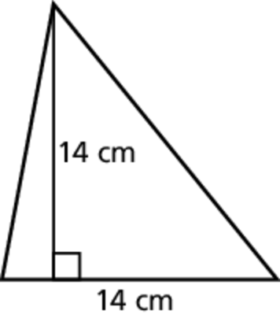
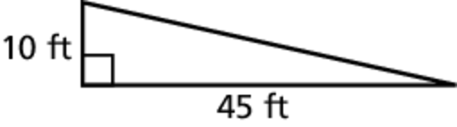
3. 4.
5. A sign is in the shape of a triangle with a base of 12 inches and a height of 8 inches. Find the area of the sign.
Find the area of the triangle.
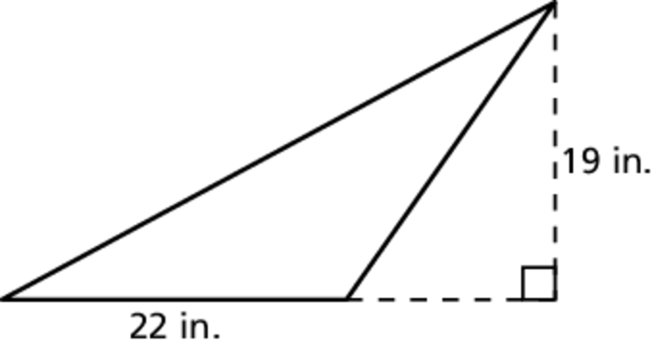
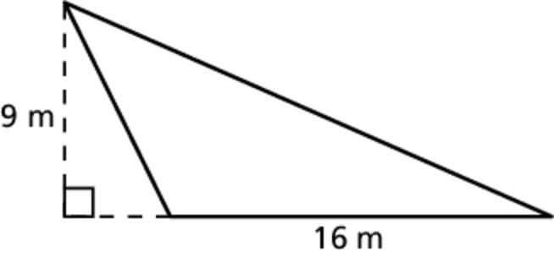
6. 7.
8. The shaded triangle in the sign has a base of
75 millimeters and a height of 65 millimeters.
The white triangle in the sign has a base of
37 millimeters and a height of 32 millimeters.
Find the area of the shaded portion of the sign.
9. You live on a triangular piece of land with a base of 121 yards and a height of 80 yards. One acre of land is equal to 4840 square yards. Find the area of your piece of land in acres.

